How to get the text?

- Open Facebook and change your view to the “classic Facebook”

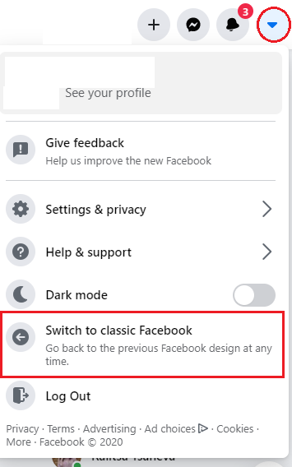

- Open: https://www.facebook.com/events/
Then find birthdays
Scroll down to the end – the same month, but the next year.

- Press F12 on your keyboard. If it’s not , choice Elements. Then press CTRL + F
to open the search bar. Find birthdays_content.
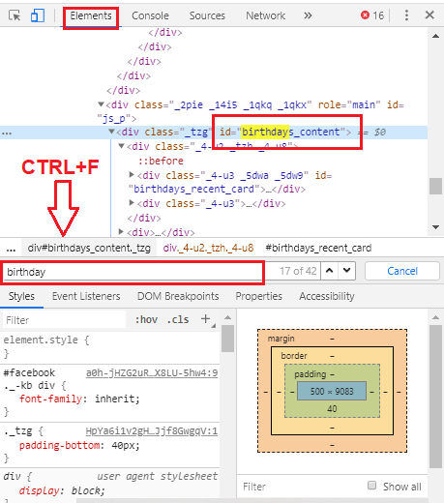

- Click the right button of your mouse and choice copy – copy outerHTML

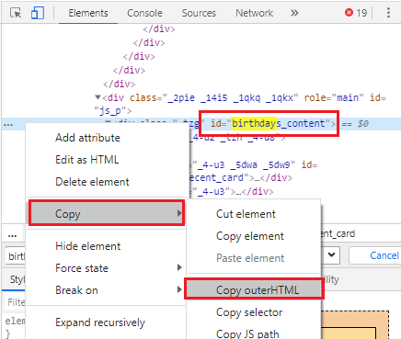

Then paste the text on: https://givanov95.github.io/birthdays-fromFB/ , wait for a few seconds and choice “Download Calendar CVS”.

